

What is share market?

What is share market? Before understanding this, what is a company? What are shares? This must be understood.

A company is a person or a group of persons when they decide to create something or provide a service, it should reach the other person in a legal manner and the person should have a proof that the service is legal. It is called a company when there is approval. This is the first issue.

Now the second issue is what are shares?

Now we understand what a company is but let us understand how a company starts and grows from the following example. As we have seen above, a company is started by a person or a group of people. 50 lakhs is required to start a company. If a son is the son of a rich father, he will take Rs 50 lakh from his father and start a company. If a company is started by a single person, that person will be the sole owner of the company.

There will be 1 share of 100%.

The profit and loss will be his. The person was the son of a rich father he started but who has no money how to start what the person will do gather 10 friends. 5-5 lakh rupees will collect 10 friends and raise capital of 50 lakhs. Less can be more, how many working partners, how many capital partners, share can be less or more. To understand, let's understand 5-5 lakh equal 10 parts.

A company started for example it manufactures ice cream. Let's say it started in Pune, many people love ice cream. 5 more branches of the company were established in Pune. There is a huge demand increase all over the country and the branch company needs to increase its production. 500 crore is required. How to raise this capital? So what a company will do is offer people a share of their company at a certain price and in return raise money from people. Suppose the company has a value of Rs.50 lakhs

So what will that company do, it will bring 5 crore

shares in the market at 100 rupees. In this 10 paise is face value and 99.90 is premium. We will see the calculations of share price = face value + premium in the next article of the article. There is a specific process to do all this which is also known as initial public offering or IPO in stock market parlance. The initial transaction between the company and the public is also called primary market.

If the public has bought the shares for Rs. 100, those shares are also to be sold to someone and also to be bought by someone. There can be many reasons why to sell or why to buy like need of money, making profit, possibility of higher profit in different company.

This is a huge research topic. Newbies need

some time to know which stocks to buy and which stocks to sell. In this way, the public buys and sells shares among themselves, it is called the secondary market in the stock market. In Marathi language Shares are called Sambhag. The place where these stocks or shares are bought and sold is called stock market.

Readers may be wondering where this market is located. We will see how this work is done in the next article.

We have started this article to provide complete knowledge of the [share market in a practical](https://sharemarketkranti.com/websitedata/home)

transparent manner. Our organization Sharemarketkranti is always working to provide transparent knowledge of share market to every person in Maharashtra.

For new updates in the share market sector, always stay updated on other platforms of your organization like Facebook, Instagram, YouTube, Twitter as well as on your website. We are publishing our article on every platform. We also provide a [Share market classes/training.](https://sharemarketkranti.com/websitedata/home)

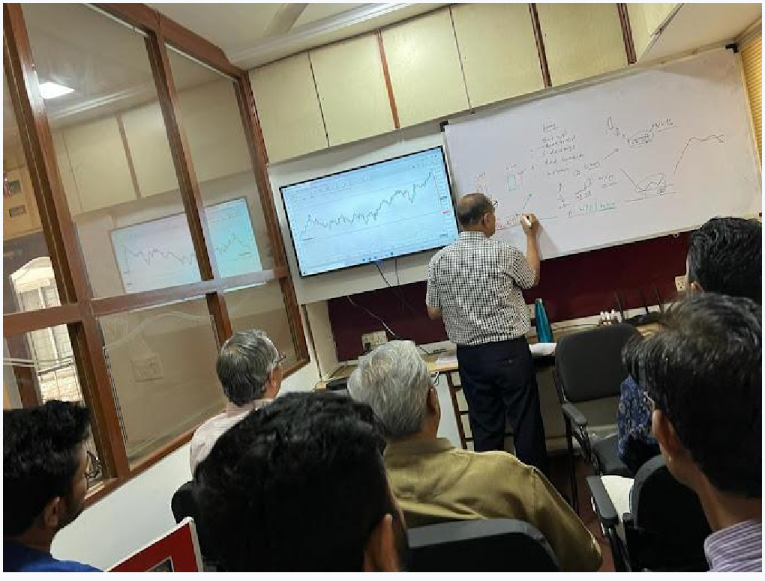

Stock market trading and the game of chess go hand in hand. Till today we have been hearing that stock market means gambling, betting, gambling or the business of big men, rich people. We always hear these things from the mouths of many people.

I want to ask a question to the readers, is the stock market really a gamble? Readers should reply through email, whatsapp or measaages. Its complete information will be available at the end of the article.

Answering this from our experience so far, if we

know in what way and how you work in the stock market and how studiously you work, then you can definitely say whether you are a gambler or not. All this to the readers, I will tell you that while working in the stock market, if you are successful in protecting your invested money, then you are definitely not a gambler.

Learn to book small profits. Even small profits should be made consistently. If you think in such a way that you don't want to make a huge profit in one day, you will never think of the stock market as a gamble.Even after thinking in this way, working at the same time, stock market gambling, if it seems speculative, I would like to say that everything in this world is a gamble, every business is a gamble, every deal is a gamble and even human life has to be called a gamble.

Let's think a little differently. Everyone knows

chess. Instead of calling the stock market a gamble, I would like to call the stock market a chess game. In chess, every wrong move of your opponent leads to your victory and every wrong move of yours leads to victory of your opponent. Every wrong move against him leads that player to defeat.

It is also the same in share, only after someone's loss, someone gets profit, this is in secondary

market. We will definitely see about the technical term secondary market in the next few articles.

Therefore, what is bought and sold in the stock market, as well as when to enter and exit is very important.

If we want to make each move or horse move in a chess game, we decide the horse move by considering where the vizier is, the camel, the elephant, the pawn. Similarly, in the share market there will be sector leaders companies, there will be competitor companies, there will be commodity market, there will be currency prices, there will be the situation of foreign exchanges, there will be stress in the country or outside the country, if there will be a war situation, if there will be an election, if there will be a budget, then all these have to be studied. After that one has to study everything and buy and sell.

There is only one difference between shares and chess, in chess you know your opponent.

Retailers do not know this in the stock market.

In this world, without study, without hard work, no business can grow or even get profit. But business is like that. There is a terrible curiosity after meeting new people. In it, before everything is known, wrong things happen

There is a lot of excitement and fear in the stock

market. Every move in the stock has to be made after considering the opposing party. While working in stock market you must remember the chess moves.

In the end, I want to tell the readers that in the stock market, everything has to be done after thorough study and information. Unlike other businesses in the stock market, a businessman knows the specific difficulties of his business.

But we have a saying that every time a new problem comes up in the stock market. A bend should be built before the water. That person is always successful. You have to always be alert in the stock market. Every time there is a new problem. One has to keep a strict watch on the moves of the opponent in the chess game. You have to know what is going on in his head.

Author:

Mr. Sanjay Balapure.

Founder & CEO. Share Market kranti.

About: Share Market Kranti comes in [best share](https://sharemarketkranti.com/websitedata/home) [market Marathi classes in Pune](https://sharemarketkranti.com/websitedata/home).Mr.Sanjay Balapure has well experience in [stock trading,](https://sharemarketkranti.com/websitedata/home) [investment and training.](https://sharemarketkranti.com/websitedata/home)